RAPPORTAGE: Nulinspectie & EMC Gap-Analyse
Project: Simonshaven 380kV Uitbreiding (DP2-4)
Client: SC&M II V.O.F.
DNV Reference: OPP-00436810-PSP 25-1757
Date: 15-1-2026
Status: First Version

Management Summary
This report documents the findings of the EMC Baseline Survey (Nulinspectie) performed by DNV at the Simonshaven 380kV substation.
Objective: To visually verify the "As-Built" EMC status of the existing Phase 1 (DP1) installation and identify specific integration risks for the new Phase 2-4 (DP2-4) expansion.
Key Conclusion:
Based on the review of the DP1 As-Built documentation [2] and from the visual inspection, it is not conclusive whether the buildings (CDG and Takhuisjes) fully comply with the TenneT Standard 380kV Zone Concept [1] regarding building shielding. Electrical bonding and continuity between cabinets, Roxtec frames and other metallic interfaces could not be confirmed through visual inspection only. Minor mitigations might be required to ensure equipotential bonding, EMC shielding mitigation. These mitigation measures will be considered as part of the scope of work for DP2-4 to ensure that the EMC zoning layout does not deviate from the original zoning concept. It is recommended that measurements be performed to verify electrical continuity to justify mitigation measures for EMC and lightning protection design compliance.

Introduction

Project Context
SC&M is executing the expansion of the Simonshaven substation (DP2-4). This involves integrating new high-voltage assets (Transformers TR412-414, Shunt Reactors, Bays 4-5) into the existing operational environment (DP1).

Scope of Inspection
The scope of this Nulinspectie is limited to:
- Visual Inspection: Verification of visible earthing, bonding, shielding, and cable routing in the existing CDG, Takhuisjes, and accessible cable trenches.
- Gap Analysis: Comparing the physical installation against TenneT Standard E04 [1] and the DP1 EMC Plan [2].
- Interface Check: Identifying physical connection points for the new DP2-4 earthing and cabling.

Dependencies & Limitations
Hidden Defects: DNV assumes that:
- Underground earthing connections (not visible) were installed according to the as-built drawings, unless visual evidence suggests otherwise.
- The EMC mesh (not visible) was installed in the walls of the CDG according to the as-built drawings, unless visual evidence suggests otherwise.

Reference Framework
The inspection evaluates the site against the following hierarchy of documents:
Ref | Document Number | Title | Status | Relevance
[1] | 1287698 (E04) | Uitwerking EMC eisen-zone concept standaard 380kV station | The Standard | TenneT's mandatory rules for zoning (LPZ) and installation details.
[2] | 2407-5582 | EMC beheersplan SMH380 (Phase 1) | As-Built | Describes the executed state of DP1, including known deviations.
[3] | 01350-01-00075 | Beoordeling EMC studie SMH380 Fase 1 | History | Previous gap analysis highlighting missing shielding mesh.

Risk Identification (Pre-Inspection Analysis)
Based on the review of Document [2] (EMC beheersplan SMH380), the following specific risks were important to be verified on-site:

- Legacy Shielding Defect: Document [2] states that the EMC mesh (30x30mm) in the CDG and Takhuisjes was "not correctly installed."
  - Risk: The rooms may effectively be LPZ 0 (Unshielded) instead of LPZ 1.
  - Inspection Focus: Verify if any wall/floor bonding points for the mesh are visible or connected.
- Cable Entry Integrity: There is ambiguity regarding the bonding of Roxtec frames and the termination of cable shields at the building entry.
  - Risk: High-frequency interference entering the building via cable shields.
  - Inspection Focus: Check physical bonding of frames to the earth bar (Detail 27 of [1]).
- PEC Continuity: It is unconfirmed if Parallel Earthing Conductors (PECs) were installed in all concrete trenches.
  - Risk: Lack of shielding for field cabling.
  - Inspection Focus: Spot-check open trenches for 50mm² Cu PECs.

Inspection Findings
This section details the observations made during the visual inspection of the Simonshaven 380kV substation (DP1 area). The inspection focused on verifying the "As-Built" status against the TenneT EMC eisen-zone concept (Document E04) and identifying deviations reported in the Phase 1 documentation.

Central Service Building (CDG)

Cable Entry Systems (Kabelinvoer)
- Inspection Scope: Visual check of the Roxtec cable transit frames in the AC/DC and Telecom rooms. Verification of frame bonding to the main earth bar and correct termination of cable shields (360° bonding) within the modules, in accordance with TenneT Detail 27.
- Observations:
  - The physical condition of the Roxtec frames was found to be Fair
  - The bonding connection between the transit frame and the room’s ring earth could not be visually observed (aardrail). It is possible that an electrical connection exists but can only be verified through measurement.
  - Regarding cable shields: It was not possible to verify shield termination visually. Recommendation that measurements should be performed to verify connection.
- Photo Reference: SMH001-SHM016
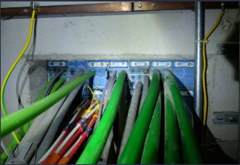
Photo reference SMH002

Room Shielding & Equipotential Bonding
- Inspection Scope: Verification of the Faraday cage concept (LPZ 2). Inspection of bonding points between the wall reinforcement (wapening/EMC-net) and the earthing system, and bonding of metal door frames.
- Observations:
  - Visible connections to the building reinforcement or EMC mesh were Observed at regular intervals
- Photo Reference: SMH019, SMH020
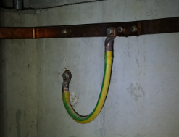
Photo reference SMH019, SMH011

Cabinet Installation (Secundaire Kasten)
- Inspection Scope: Check of cabinet earthing and cable gland plates (wartelplaten) in the CDG server/telecom room.
- Observations:
  - Cabinets are earthed via Short flat copper litze wire and long round yellow-green wire (Pigtail) – this is found to be inconsistent and not a good practice. For new modifications, conform to TenneT standards more strictly.
  - Cable entry into cabinets is via Conductive gland plates with EMC glands: It was not possible to visually confirm the consistent implementation of EMC glands. For new modifications, conform to TenneT standards.
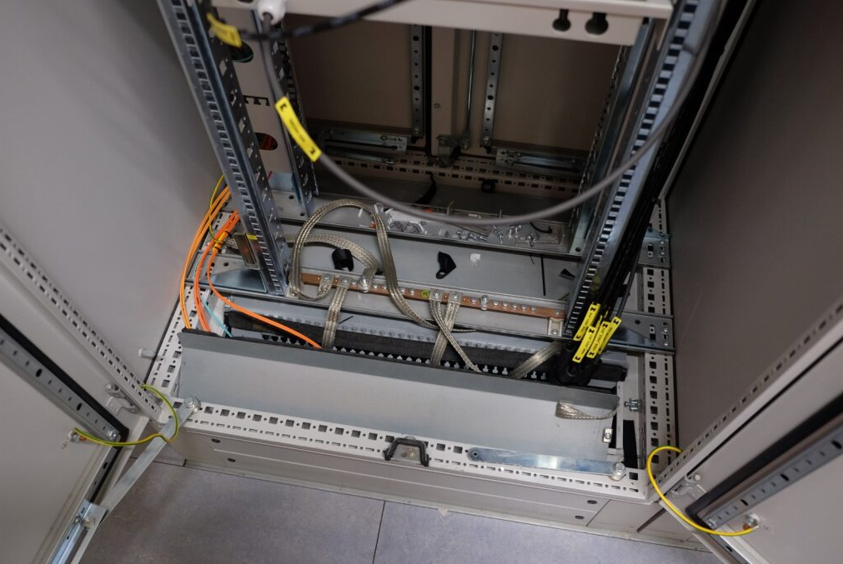 | 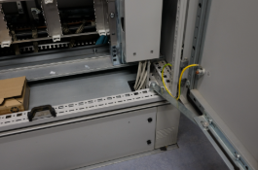
Photo reference SMH011, SMH012

Bay Houses (Takhuisjes)

Building Shielding Integrity Takhuisje 2
- Inspection Scope : Verification of the "Missing Mesh" deviation noted in previous reports. Check for visible earth bars connected to the wall structure.
- Observations:
  - The inspection Could not confirm the presence of the 30x30mm EMC mesh described in the design. For new modifications, conform to TenneT standards.
  - Earth bars (aardrails) on the walls are connected to the building reinforcement at the required intervals (max 5m). The detailed measurements between the connections were not taken but for new modifications, conform to TenneT standards.

Secondary Equipment Earthing Takhuisje 2
- Inspection Scope: Check of protection relay cabinets and auxiliary power distribution boards.
- Observations:
  - Cable connections of the cabinets were found to be Inconsistent and included plastic connection lugs. It might be that for some of the cables (for example, fibre optics), the EMC compliant connection lugs are not required. The specific cable connections that do not comply therefore need specific identification to inventorize the non-conformances. For new modifications, conform to TenneT standards.

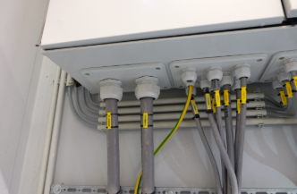 | 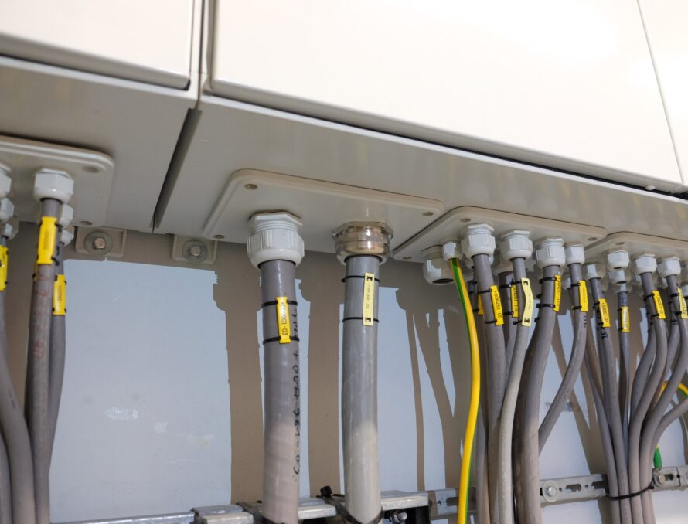

Photo reference SMH036, SMH038
In Takhuisje 3, a more consistent approach was followed as seen below in the metallic cable lugs:
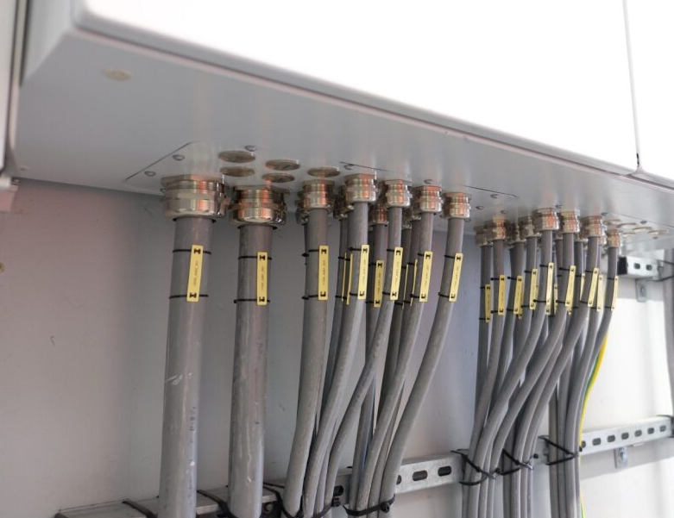
Photo reference SMH063 (Takhuisje 3)

Field Infrastructure (Buitenterrein)

Concrete Cable Trenches (Kabelgoten)
- Inspection Scope: Covers were not lifted but presence of a Parallel Earthing Conductor (PEC) was visible and terminated inside the Takhuisjes.
- Observations:
  - Location 1 (Near CDG): A copper PEC (≥50mm²) was visible terminating inside. No External PEC was identified.
  - Location 2 (Near Tak 1): A copper PEC Was visible inside all Takhuisjes
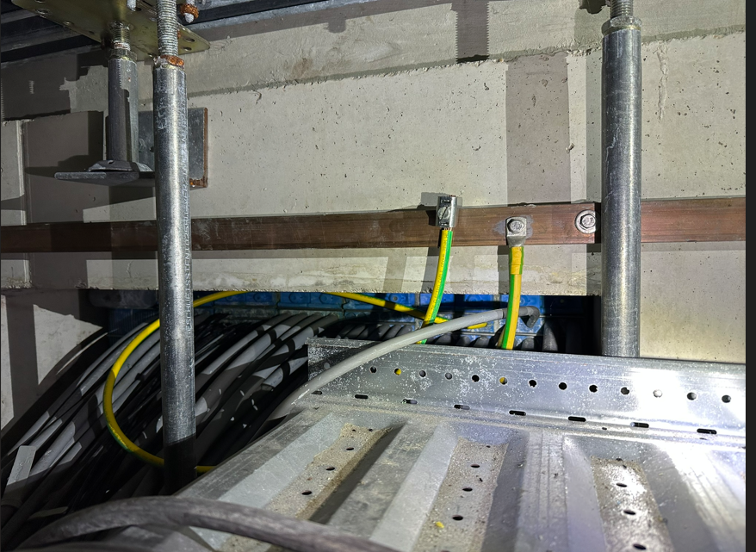
Photo reference IMG_6485

Primary Equipment Bonding
- Inspection Scope: Not all structures were inspected as this is an earthing and bonding scope of work and not EMC. However, Visual check of earthing connections of the lightning termination rod were captured (TenneT requirement: 2x connections for main structures).
- Observations:
  - Corrosion: Galvanic corrosion was observed at bonding points (See SMH045 in Section 7).
  - Poor Contact: Lugs were observed bolted directly to painted surfaces, creating high resistance (See SMH056 in Section 7).
  - Non-Compliant Connectors: Plastic connectors were observed on field equipment (See SMH051).
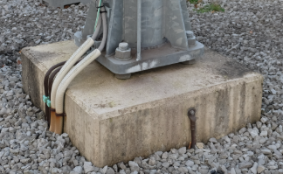
Photo reference SMH048

Fence Earthing (Hekwerk)
- Inspection Scope: Verification of earthing straps between fence panels and connection to the station earth grid to prevent touch voltage hazards.
- Observations:
  - Flexible earthing straps between fence panels are Missing in some sections / Broken.
  - Connection to the main earth grid was Not visible in all locations.
- Photo Reference: SMH052-SMH061

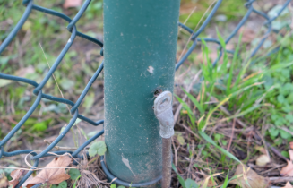
Photo reference SMH054

General Observations
Housekeeping: The general level of EMC housekeeping (e.g., loose wires inside cabinets, clippings, metal debris in cabinets) Needs Improvement.

Gap Analysis & Recommendations for DP2-4

Confirmed Deviations
Based on the inspection, the following deviations from TenneT Standard [1] are confirmed in the existing DP1 installation:
- Deviation 1: CDG Building Shielding is ineffective until proven through measurements that effective shielding is indeed present.
- Deviation 2: Takhuisjes have various findings. Secondary cabinets are not properly connected with metallic glands with the exception of Takhuisje 3. Excessive cabling is already installed, especially at Takhuisje 1 – It will be very difficult practically to install new cables. New Takhuisje EMC design to conform to TenneT standards.

Verification of Pre-Inspection Risks
The specific risks identified in Section 4.1 were verified during the site audit as follows:
Risk Item (from Sec 4.1) | Site Observation | Status
1. Missing Wall Mesh | Connections were visible in the CDG. In Takhuisjes, some connections were observed. | Should be verified through measurement to check electrical continuity.
2. Roxtec Frame Bonding | Visually confirmed Defect. Frames are oxidized and lack dedicated bonding straps (See Photo SMH002). | Confirmed Deviation visually. It should be confirmed through measurement.
3. PEC in Takhuisjes | PECs were terminating in Takhuisjes. | Compliant. It should be confirmed through measurement.

Implications for DP2-4 Design
To ensure EMC compliance for the new expansion despite these legacy issues, DNV recommends the following strategy for the DP2-4 design:
Mitigation (Cabinet Level):
  - Strict Enforcement of EMC Glands: All new entries must utilize conductive EMC glands (brass/nickel-plated). Plastic connectors are strictly prohibited.
  - Cable Management: Strict prohibition of "service loops" (coils) inside EMC cabinets. Cables must be cut to length and use flexible litze according to the TenneT Standard..
  - Surface Preparation: All bonding points (doors, mounting plates) must be free of paint before lug connection to ensure low-impedance contact.

To close the gaps identified during the visual inspection and Section 4.1 desktop review, DNV recommends the following measurements prior to finalizing the DP2-4 design:

Low-Impedance Continuity Checks
- Scope: Roxtec frames, Steel Door Frames, and Cabinet Gland Plates.
- Objective: Verify electrical continuity to the Main Earth Bar (MEB).
  - Roxtec Frames: Confirm if oxidation (Photo SMH002) has compromised the bond.
  - Cabinets: Confirm if the use of plastic connectors/glands has isolated the cable entry plates from the earthing system.

Additional Comments on Photos from Nulinspectie

CDG Building

1. IMG_6466 (1 to 4 – Possible cables with shields passing through base plate without shields being bonded to base plate or via EMC glands).

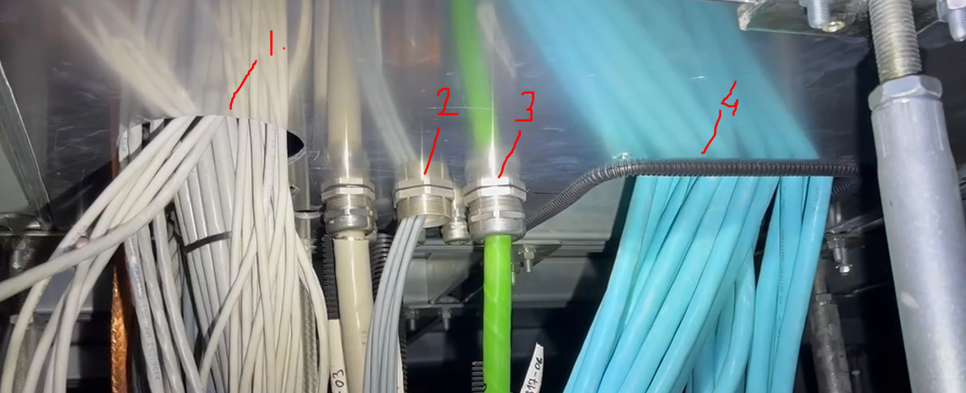

2. IMG_6466 ((1) – Excess cable coiled – coiled cable with shield exposed to magnetic fields and passing through base plate without shield being bonded to plate or via EMC gland (2)).

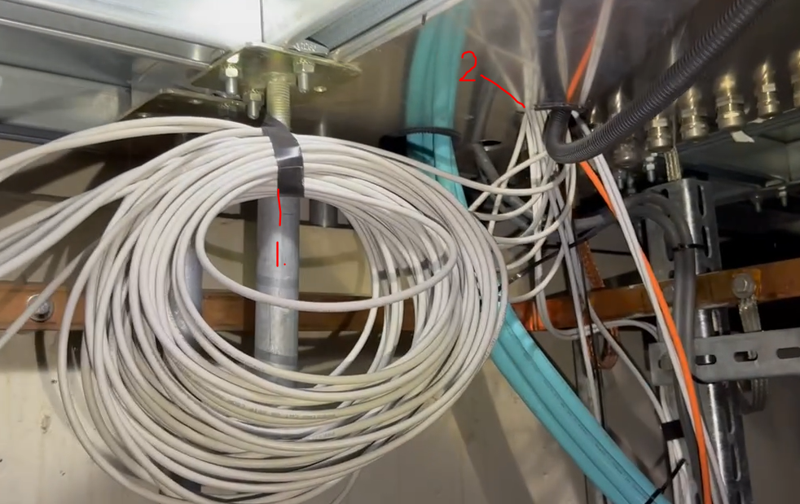

3. IMG_6466 (Good example of cable shields being bonded to base plate).

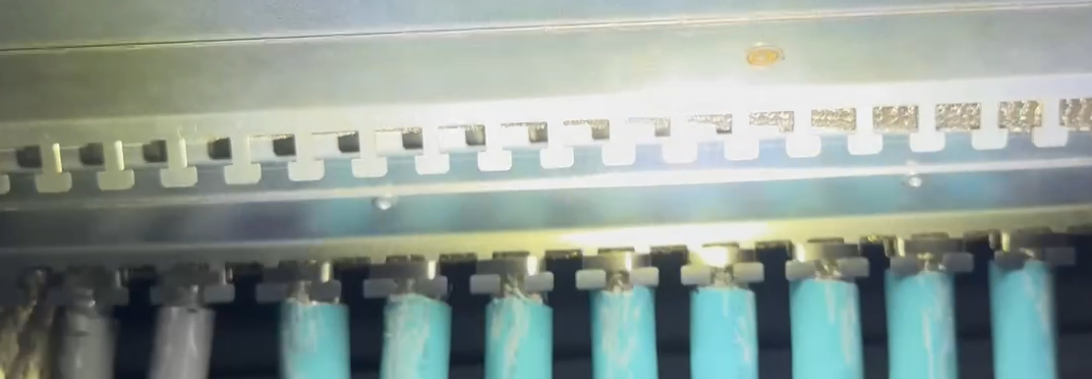

4. IMG_6467 (Good example of cable shields being bonded to base plate).

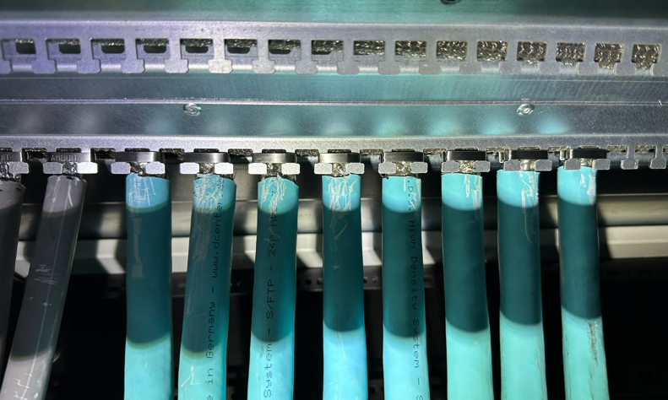

5. IMG_6469 (1 – Possible cables with shields passing through base plate without shields being bonded to base plate via EMC glands).

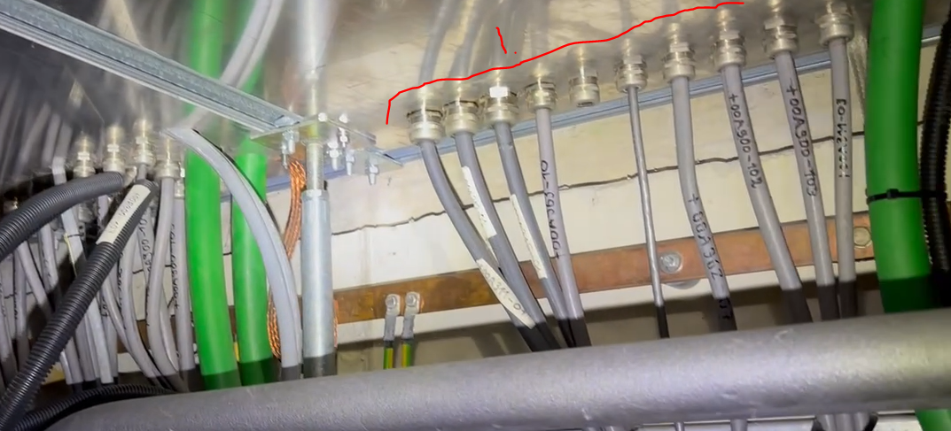

6. SMH002 (Is Roxtec metal frame bonded to earth – as discussed).

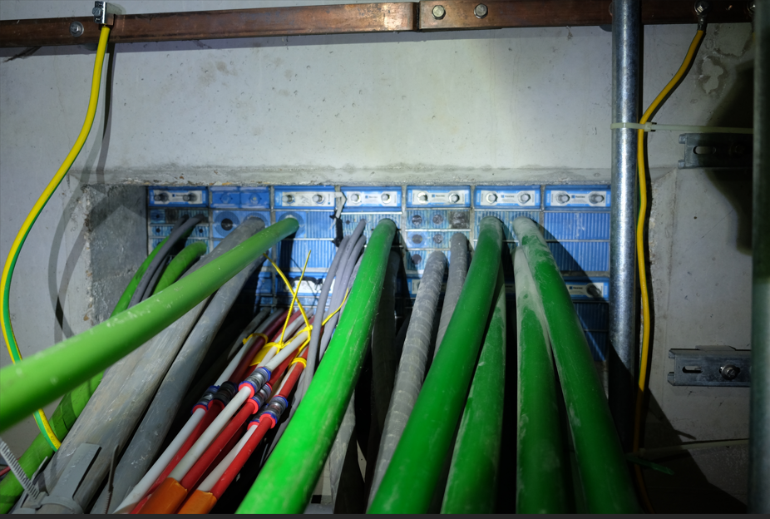

General HV Yard

1. SMH045 (Example of corrosion – most likely caused by dissimilar metals).
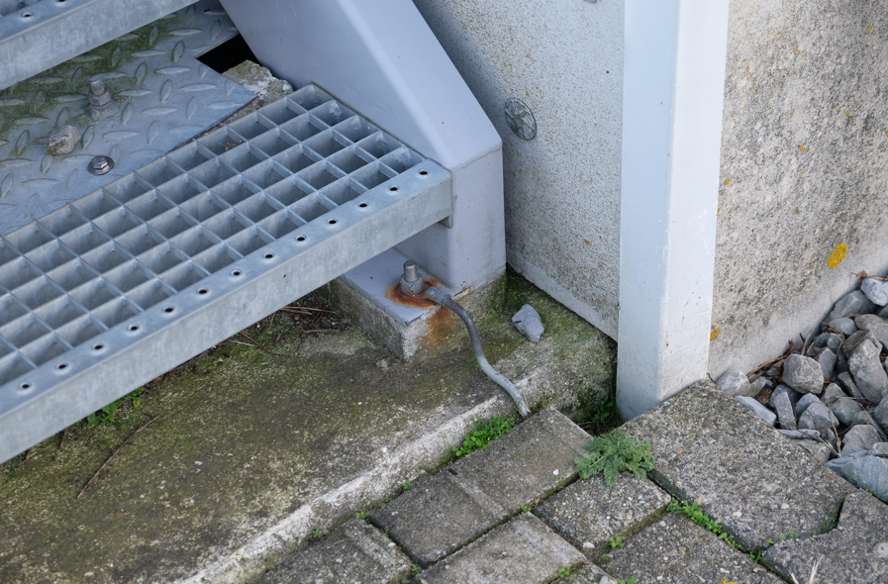
2. SMH051 (Appears to be plastic connectors that are not EMC compliant).

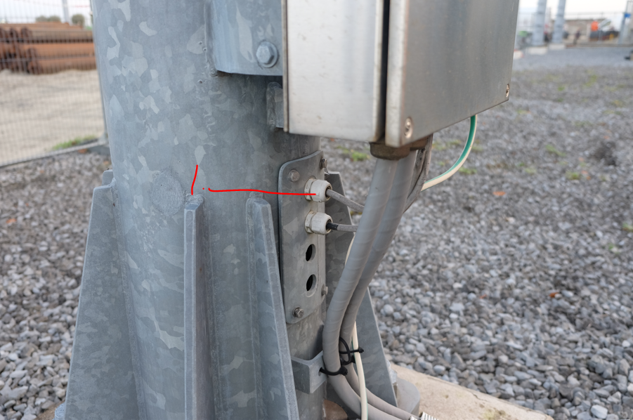

3. SMH056 (Poor electrical contact (lugs on paint and not metal)).

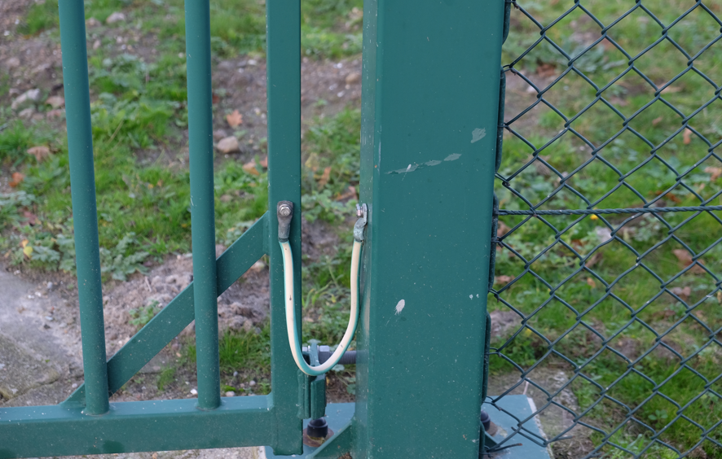

Takhuisje 1

1. IMG_6491 (Appears to be plastic connectors that are not EMC compliant).

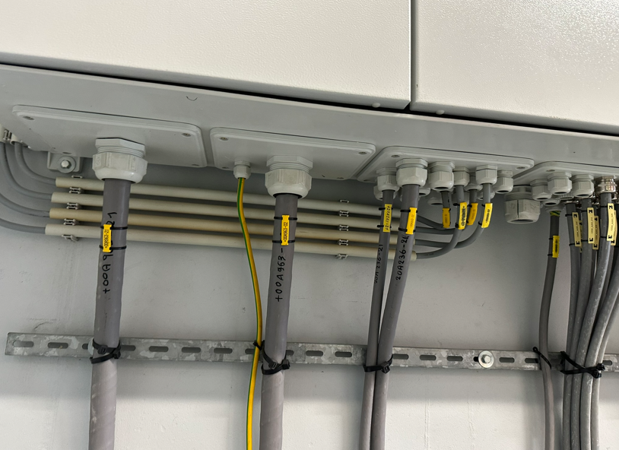

4. IMG_6492 (Good example of use of EMC connectors – bonding of cable shields to enclosure to be confirmed by measurement).

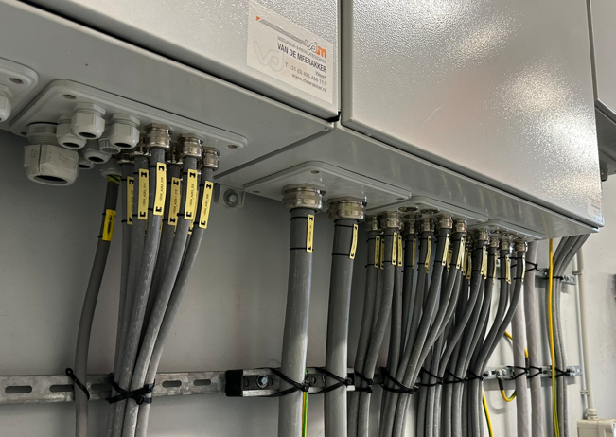

Takhuisje 2

1. IMG_6470 ((1) – Possible cables with shields passing through base plate without shields being bonded to base plate or via EMC glands). (2) – Excess cable coiled – coiled cable with shield exposed to magnetic fields and passing through base plate without shield being bonded to plate or via EMC gland).

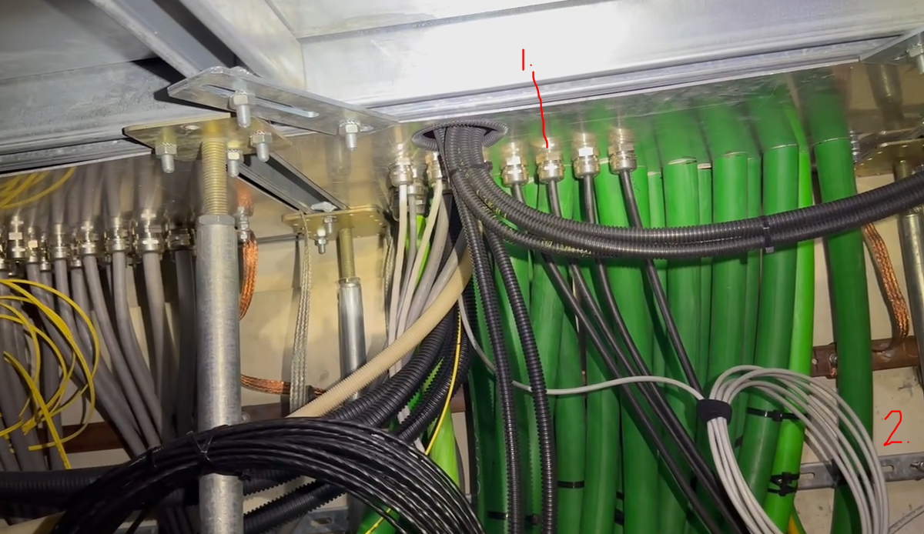

2. SMH042 (Appears to be plastic connectors that are not EMC compliant).

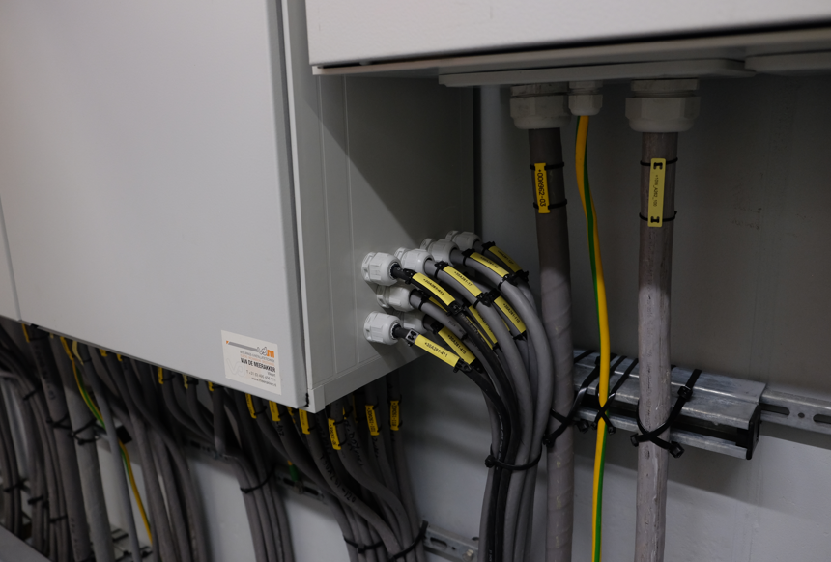

Takhuisje 3

1. SMH064 ((1) and (2) appears to be plastic connectors that are not EMC compliant).

